UMGC CMSC 495

WEEKLY Project Status Report

|  |
| --- |
| Project Name: Team 3 USACE Work Request Application |
| Date: 20211116 (Week 4) |
| Project Manager: Dave Leake |

# 1.0 Milestones and Schedule Dates

|  |  |  |
| --- | --- | --- |
| **Milestones** | **Estimated Completion Date** | **Percent**  **Complete** |
| User Guide | 20211106 | 100 |
| Test Plan | 20211108 | 100 |
| User Experience | 20211109 | 100 |
| Design | 20211116 | 75 |
|  |  |  |

# 2.0 Accomplishments This Period

## 2.1 Activities

Project Management Burndown

First google meeting to hash out the IDE environment

DDL / DML / CRUD Concepts reviewed to Team

## 2.2 Activities Planned But Not Achieved

Complete configuration of IDE

## 2.3 Deliverables Completed

SQL Installation

User Experience

## 2.4 Deliverables Planned But Not Completed

N/A

# 3.0 Accomplishments Planned for Next Period

## 3.1 Activities

Design a user interface and related structures

Test DB Access / Document Target DB with Red Gate

## 3.2 Deliverables

High-Level Design Document

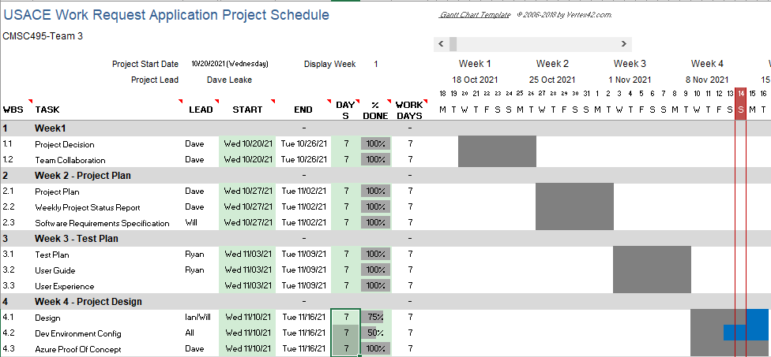

# 4.0 To Date Earned Values

|  |  |  |  |  |  |  |  |  |
| --- | --- | --- | --- | --- | --- | --- | --- | --- |
|  | PV | AC | EV | CV | SV | CPI | SPI | EAC |
| Current | 32000 | 27500 | 37500 | 10000 | 5500 | 1.36 | 1.17 | 49500 |

|  |  |  |
| --- | --- | --- |
| * Earned Value Indicators: | | |
| * PV = Planned Value or Budgeted Cost of Work Scheduled * AC = Actual Cost of Work Performed * EV = Earned Value or Budgeted Cost of Work Performed, | * CV = Cost Variance * SV = Schedule Variance * CPI = Cost Performance Index | * SPI = Schedule Performance Index * EAC = Estimate at Completion |

20211114DL:

Cost is now 7500 ($2500 per active team member) per week of deliverables, new Total Budgeted Cost is reduced to 67500

20211106DL:  
1. I miscalculated the Cumulative Planned Value (PV) in the Week 3 submission as well, you must add the LAST PV from PRIOR week to the Total Budgeted cost of the CURRENT Week to get the CURRENT week’s PV.

2. EV is now correct as well. A task remains 100% done as the weeks progress. This miscalculated the Cumulatvie EV if you don’t put 100% in the subsequent weeks.

3. Actual Cost for week 4 is now on budget. The remaining team members have stepped up with the pace and output remains consistent.

UMGC CMSC 495

# 5.0 Risks and Issues Summary

## 5.1 New

[List the new major risks or issues that will be addressed in the next period.]

|  |  |  |  |
| --- | --- | --- | --- |
| Risk/Issue # | Description | Action | Owner |
| Changes to IDE | Chosen products licensing may impede this project and force another route | Research new terms. Provide COAs. | IAN |
|  |  |  |  |
|  |  |  |  |

## 5.2 History

[List the previous major risks and issues for the project. The Project Risk Log, AMC-PMO-307, and the Project Issue Log, AMC-PMO-310, may be attached for further support.]

|  |  |  |  |
| --- | --- | --- | --- |
| Risk/Issue # | Description | Status  (Open/Closed) | Owner |
| Employee Skills | Need to gauge current team member skill sets, leverage where appropriate | Work with Team members to gauge | Dave |
|  |  |  |  |
|  |  |  |  |

# Change Request Summary

[List the changes requested that might impact scope, schedule, and cost.]

|  |  |  |  |
| --- | --- | --- | --- |
| Change ID # | Description | Change Request Type  (Defect Repair, Enhancement, Addition, etc.) | Status |
| OverTime Request | Need to approve overtime to participating team members to keep project on schedule | Personnel Shortage | Submitted |
| Azure | Azure Server Stood Up for consideration | Enhancement for ease of access | Submitted |
|  |  |  |  |